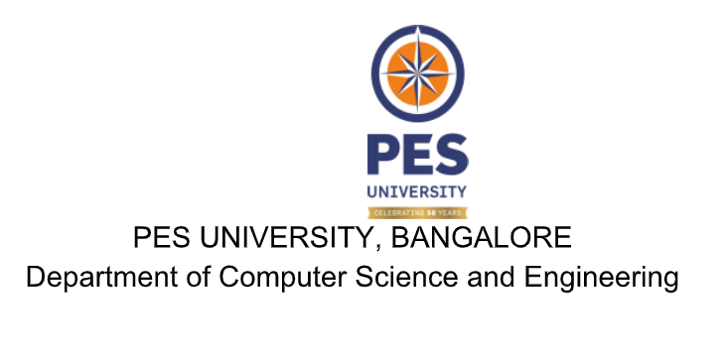

**BTECH(CSE)**

**UE20CS301- DATABASE MANAGEMENT SYSTEMS**

**MINI-PROJECT REPORT**

**ON**

**TITLE: E-NEWSPAPER PORTAL**

**SUBMITTED BY**

|  |  |
| --- | --- |
| **NAME** | **SRN** |
| KESHAVADITHYA.S | PES1UG20EC304 |
| K S RAGAHAVENDRA | PES1UG20EC302 |
| KRISHNA S BALU | PES1UG21EC912 |
| GOKUL MVSS | PES1UG21EC105 |

**JANUARY-MAY 2023**

**DEPARTMENT OF COMPUTER SCIENCE AND ENGINEERING**

**BENGALURU – 560100, KARNATAKA, INDIA**

**PROJECT SYNOPSIS :**

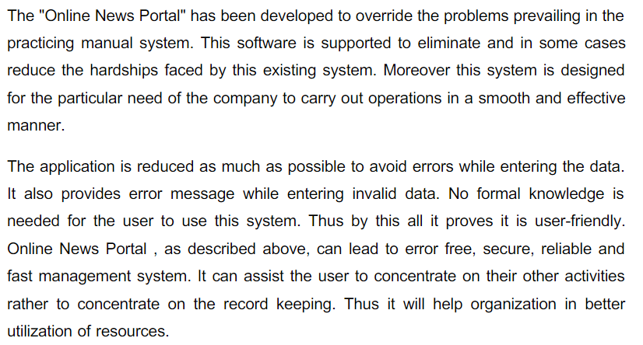

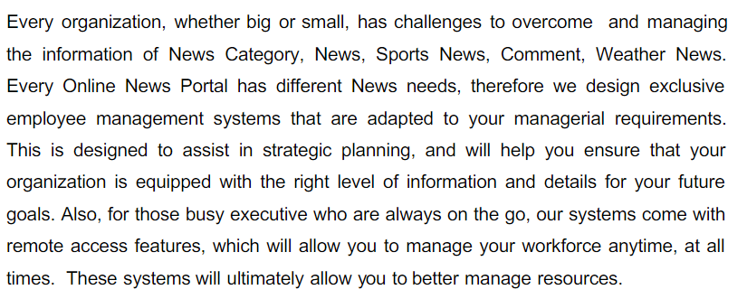

**ER Diagram:**

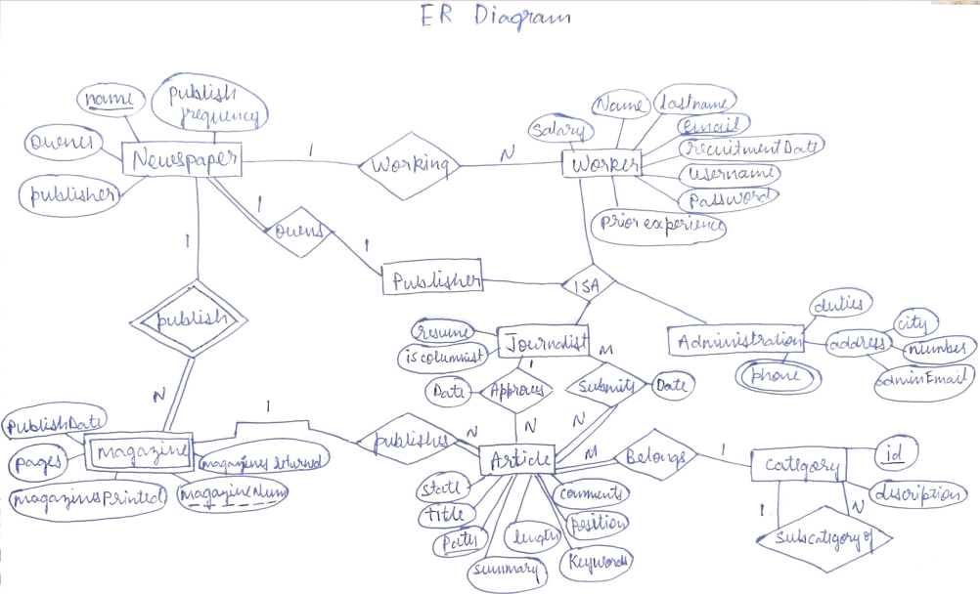

**Relational Schema:**

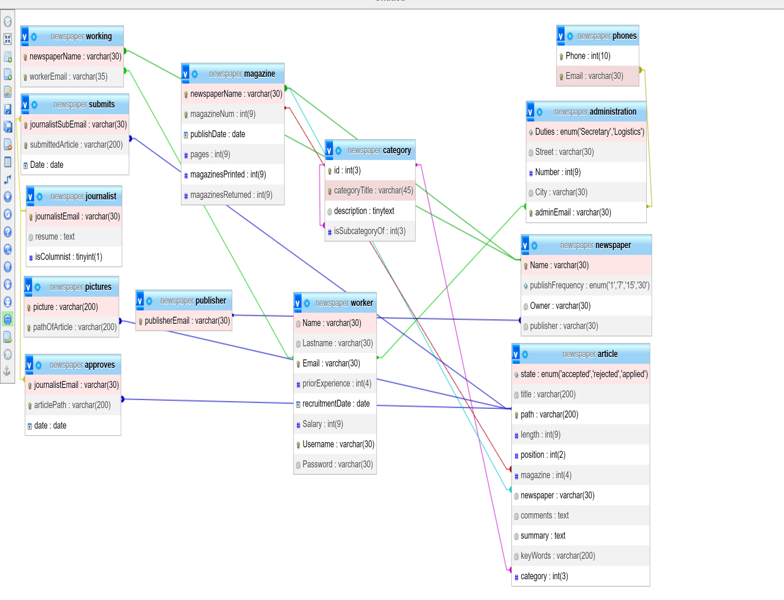

**Backend:**

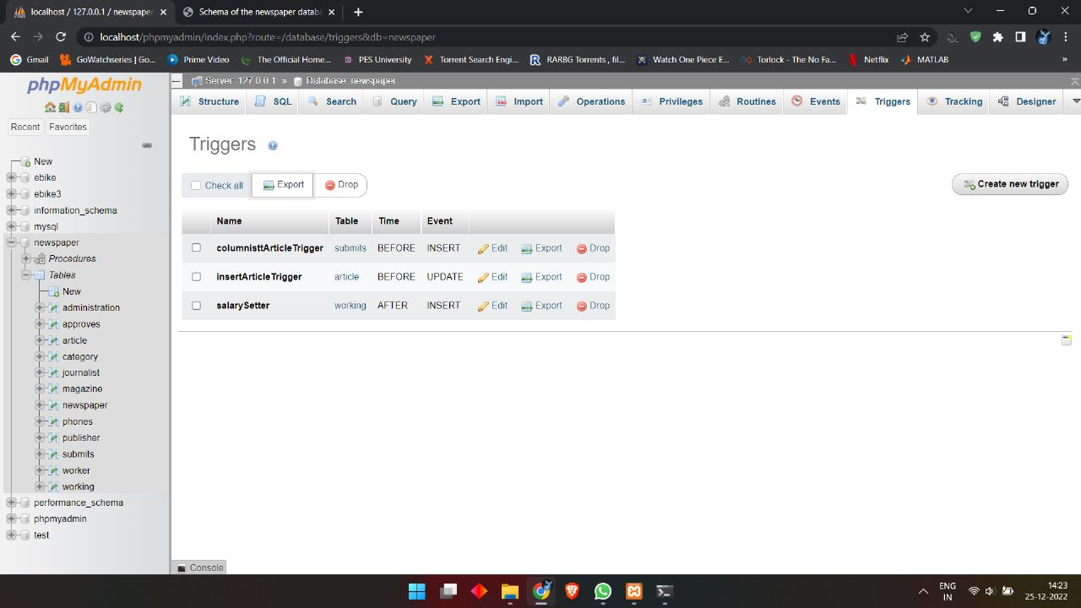

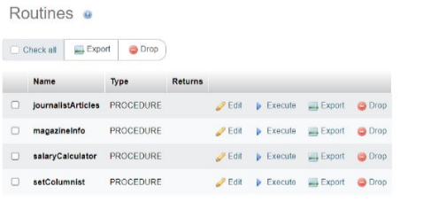

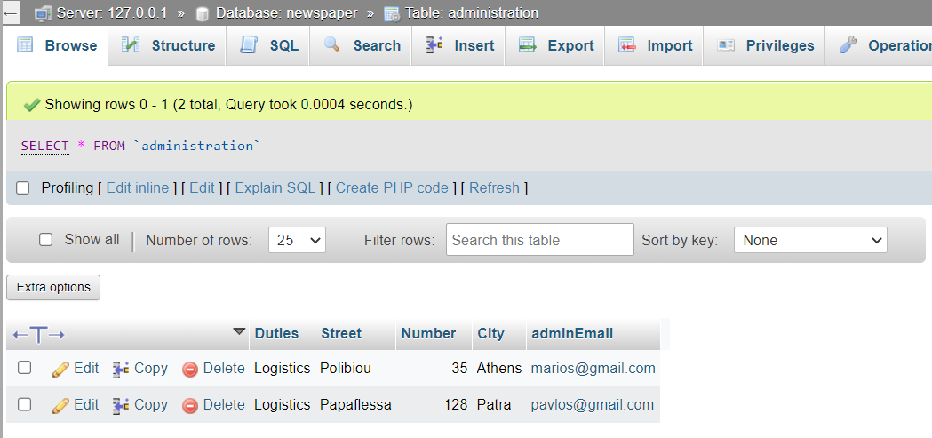

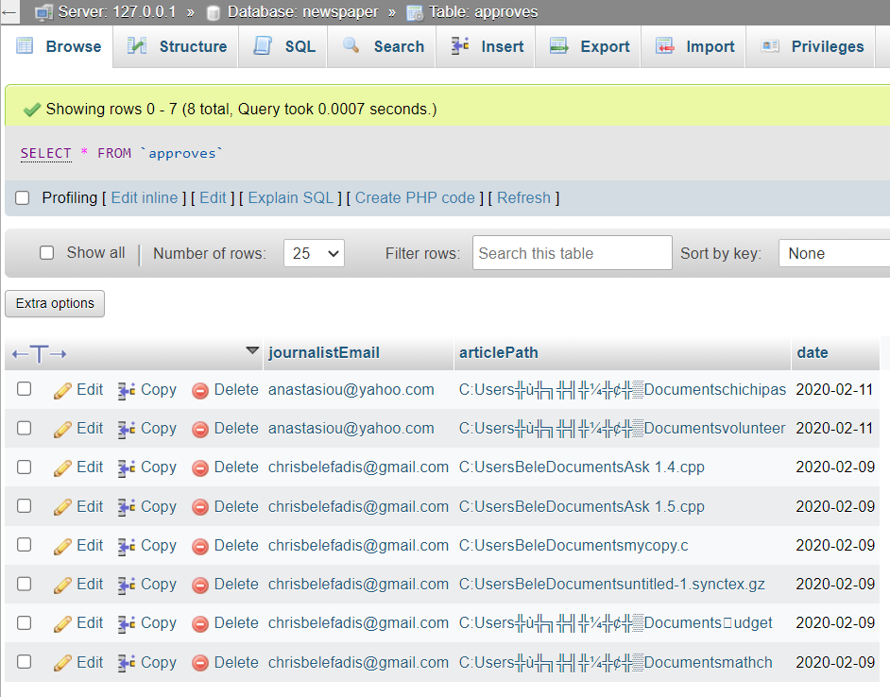

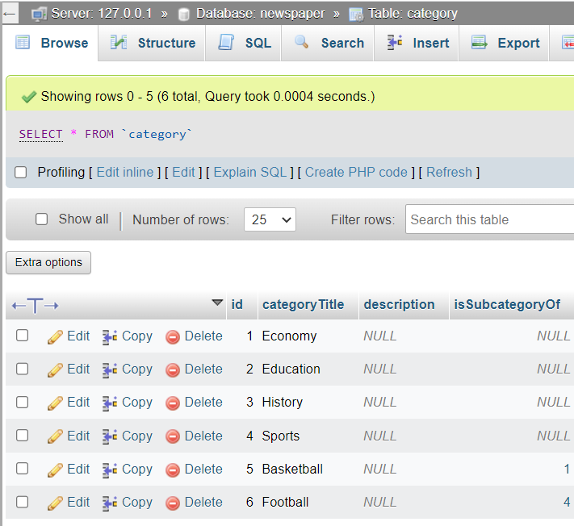

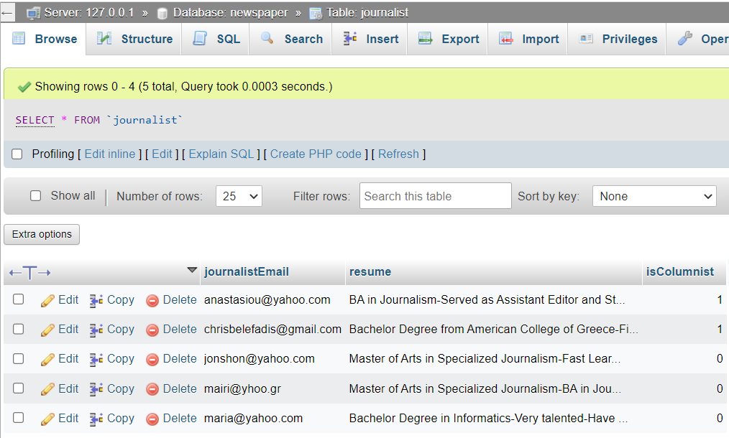

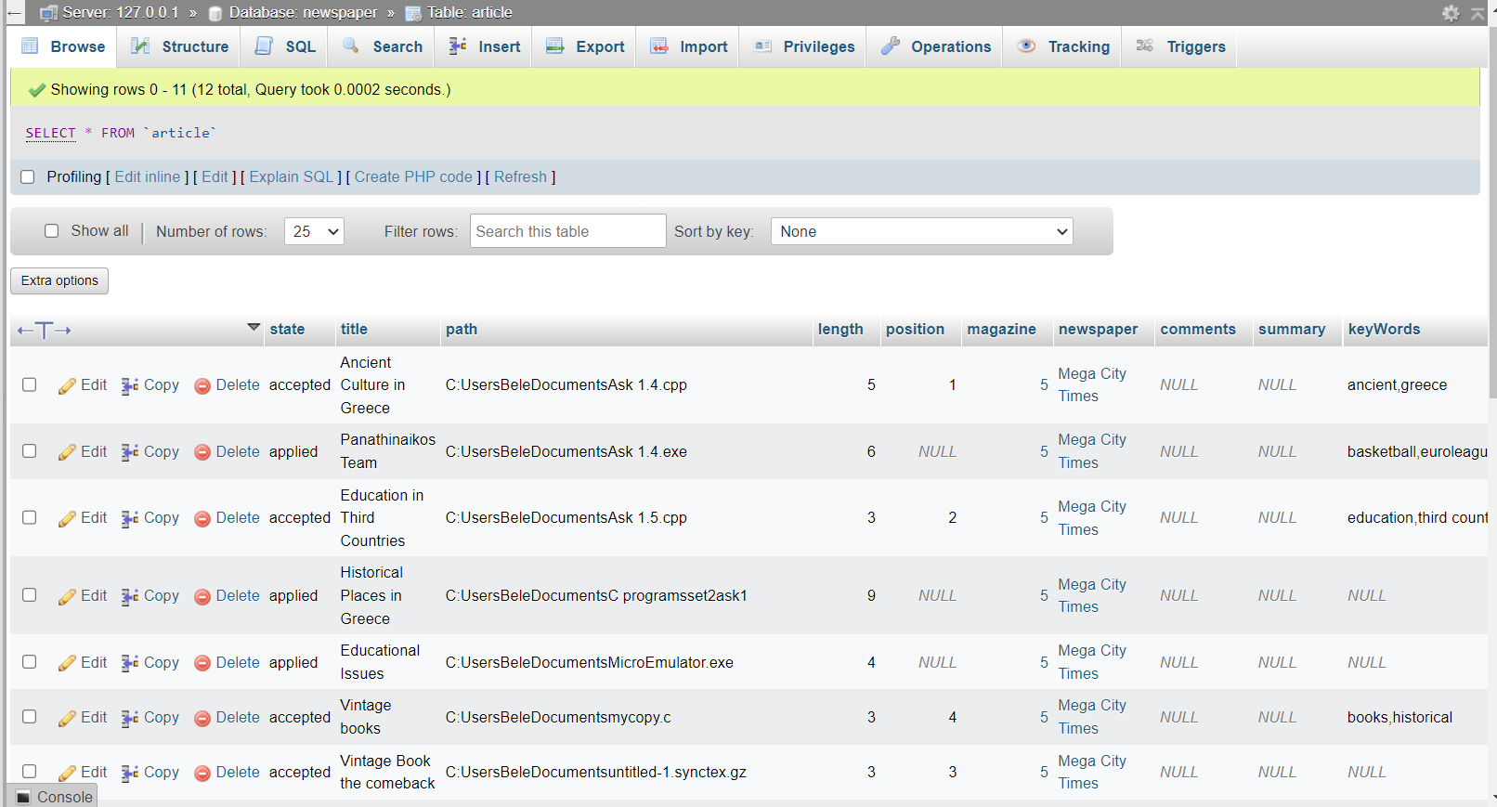

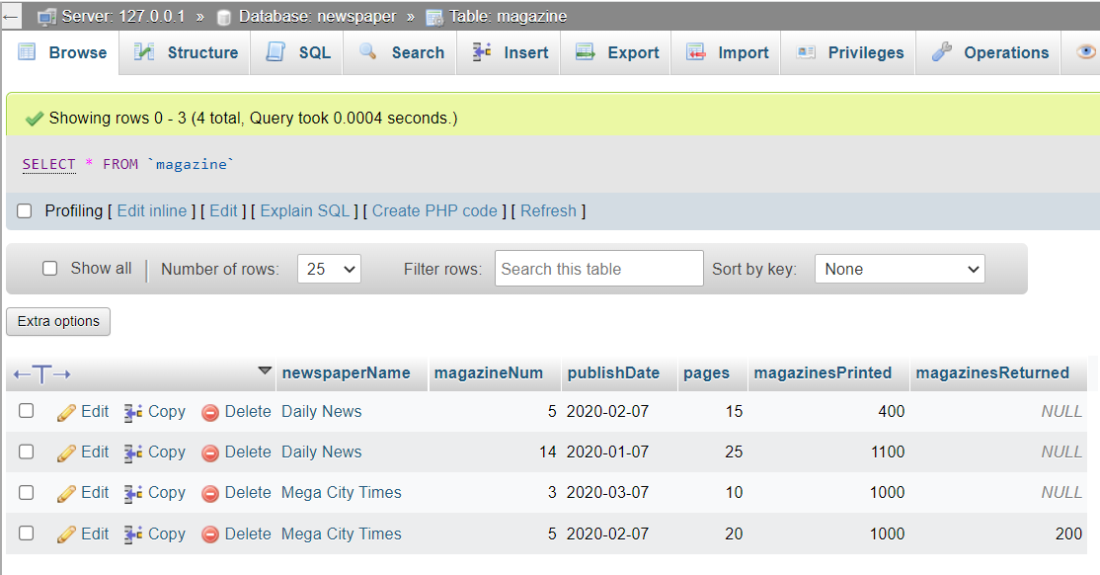

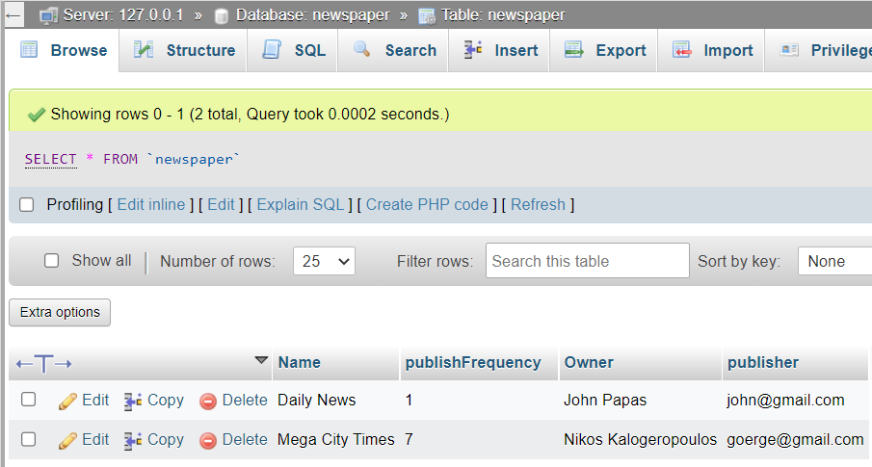

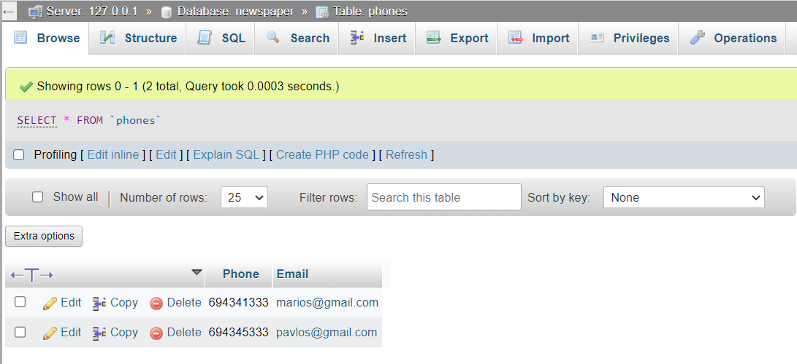

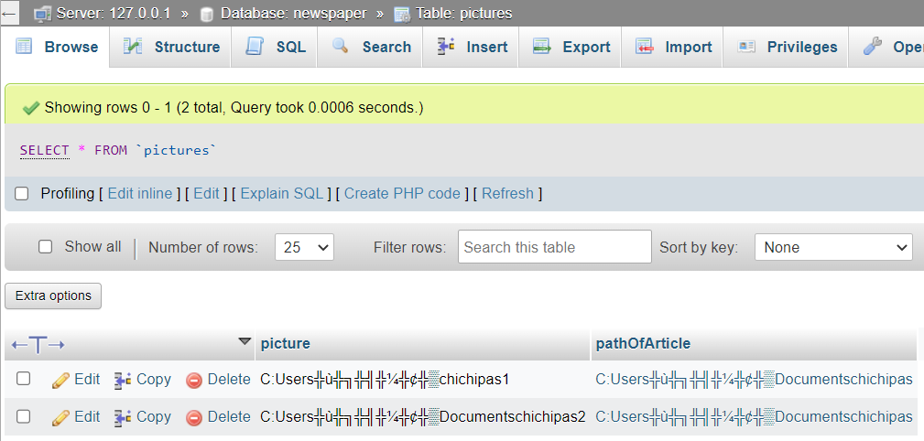

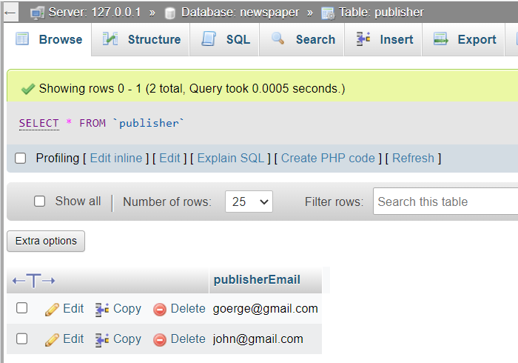

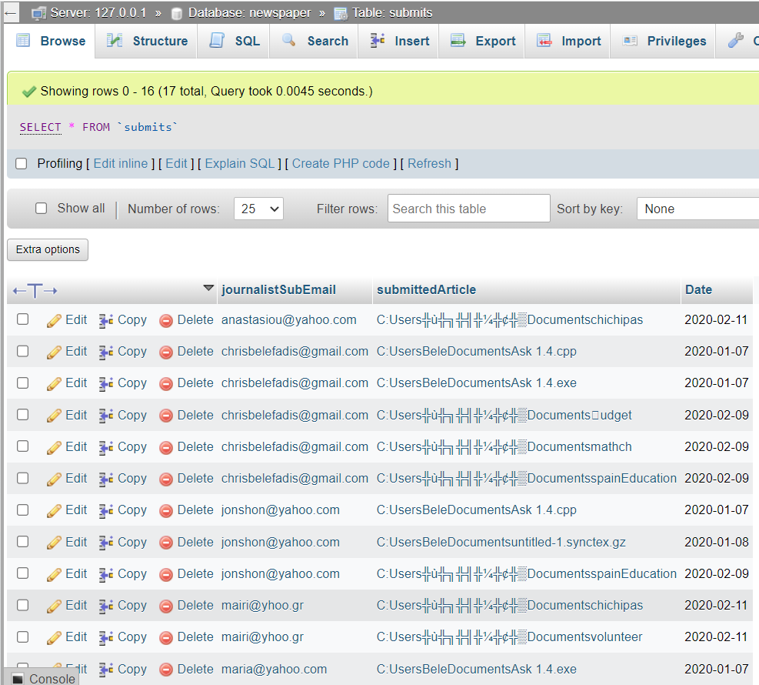

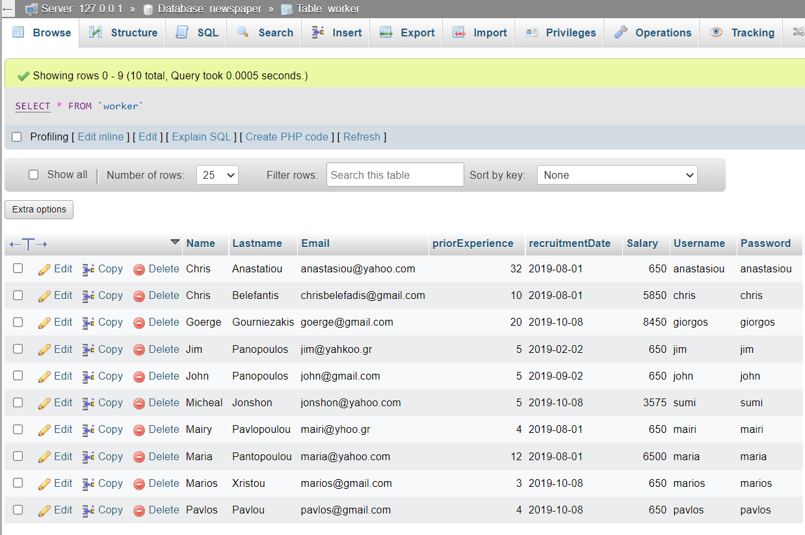

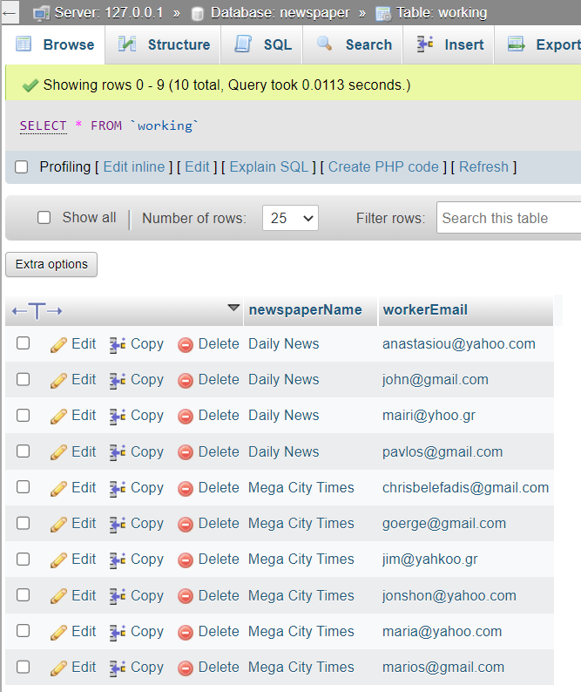

**All the Queries, Triggers/procedures is incorporated in the frontend and all the project related file will be mailed.**

**Front End:**

